Home Page

Logged In

Header
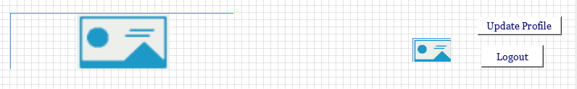

Menu
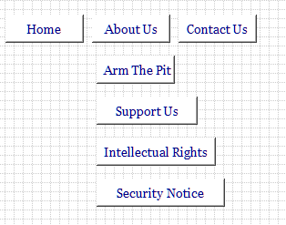

Jumbotron
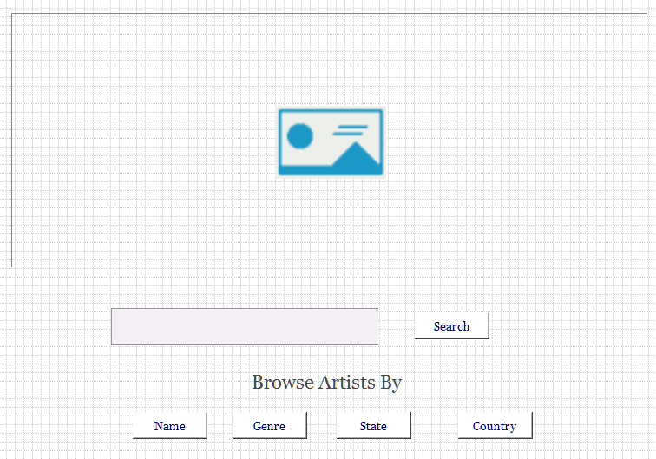

Artist Page
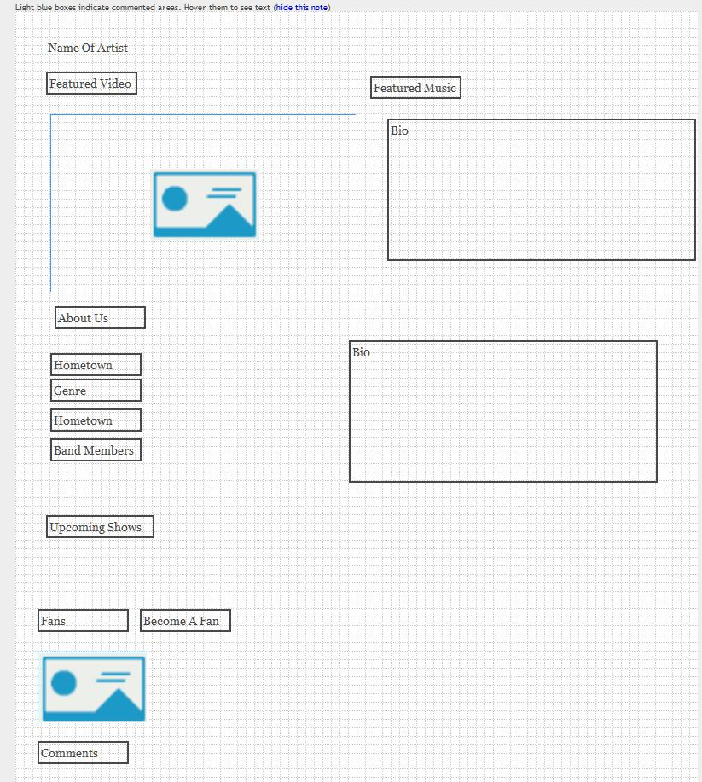
- Will read from the Mongo database.
- Will show the youtube video.
- Will read thru the song array and build audio player for the music.
- Will read thru for the fields.
- Will read thru the bio array to build the bio.
- Will read thru the Mongo show calendar and show all shows with date => later than current date.
- Will check to make sure fan is logged if become fan is clicked. Will also check to make sure have become fan previously.
- If not a fan previously will add artist id to the fan array of bands for fan.
- Will show all comments from the comment database.
- Will check to make sure fan is logged if add comment is clicked.

Footer
