Browse Artists By Country

Not Logged In

Header
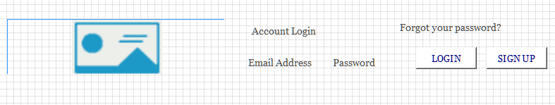

Menu
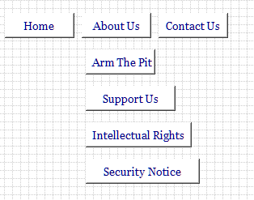

Jumbotron

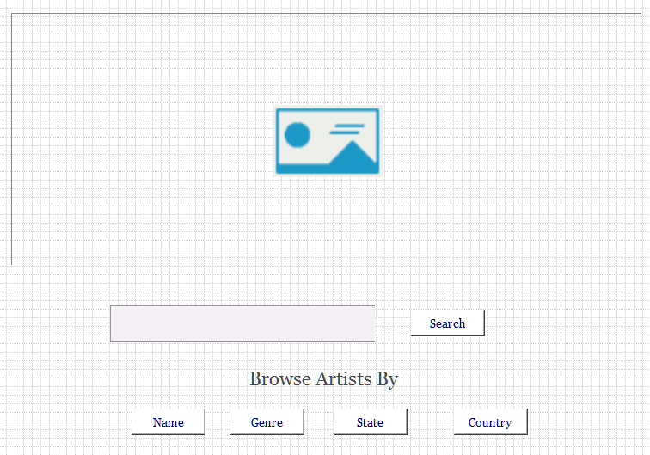 Body

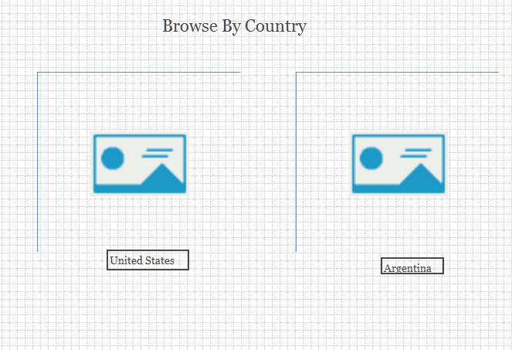

- Will show a picture of every country where an artist has signed up.
- When you click on the United States it will take to the initial page and show you all the states.
- When you click on a country it will show the artists from that country.

Footer
