Sign Up - Artist

Not Logged In

Header
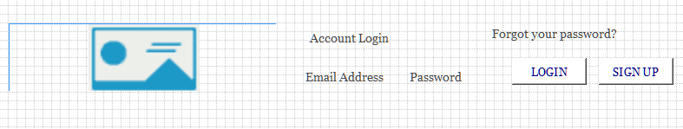

Menu
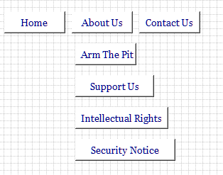

Jumbotron
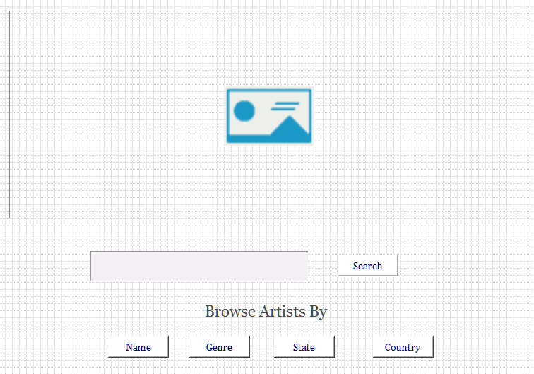

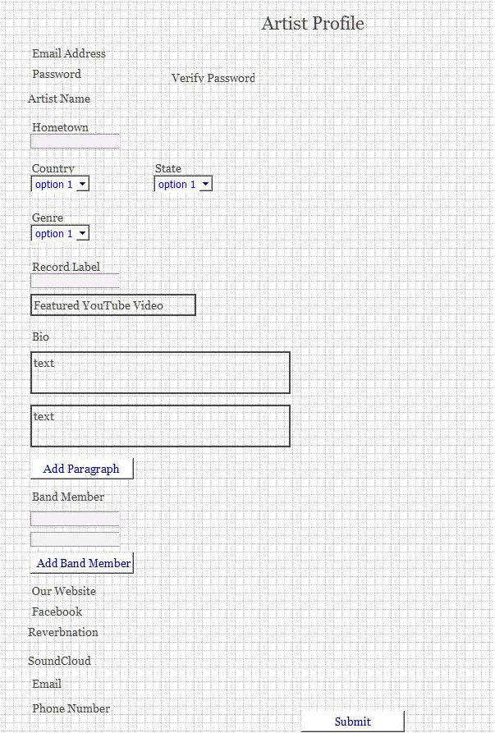
- This is the sign up page for a new artist.
- The country drop down will be all current countries.
- The states will only show if the United States is selected from country.
- The genre drop down will show all genres.
- Feature youtube video will be a url from youtube. Will check to see if it’s a valid youtube link.
- Bio will be an array that is build by entering a paragraph and press new paragraph. It will show the paragraphs as they are entered. Will have a way to edit a previous paragraph.
- Band members will be an array build by entering each band member. . It will show the Band members as they are entered. Will have a way to edit a previous band member.
- Websites: Artist, Facebook, Reverbnation, SoundCloud, Twitter, Youtube Channel, Other website1, other website2
- Representive of band. Name, email, and phone.

Profile Pic
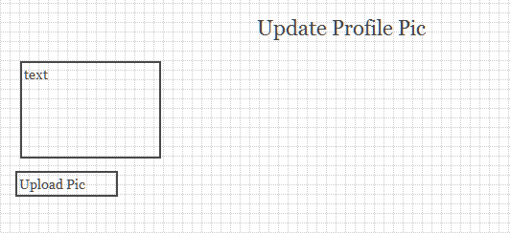
- Will show up after profile form submitted. Will hold onto the id assigned by Mongo. The picture will be save to Firebase
- The firebase url will be written back to the artist record.

Music
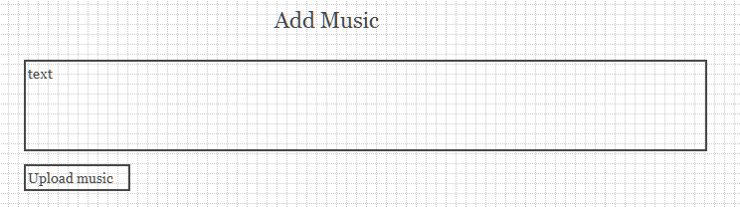
- Will show up after profile form submitted. Will hold onto the id assigned by Mongo. The music will be save to Firebase
- The firebase url will be written back to the artist record.
- The artist will be limited to 5 songs.

Footer
