Sign Up - Fan

Not Logged In

Header
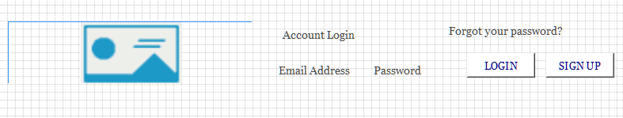

Menu
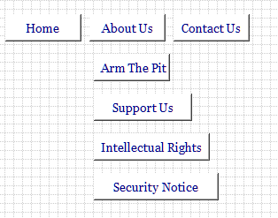

Jumbotron
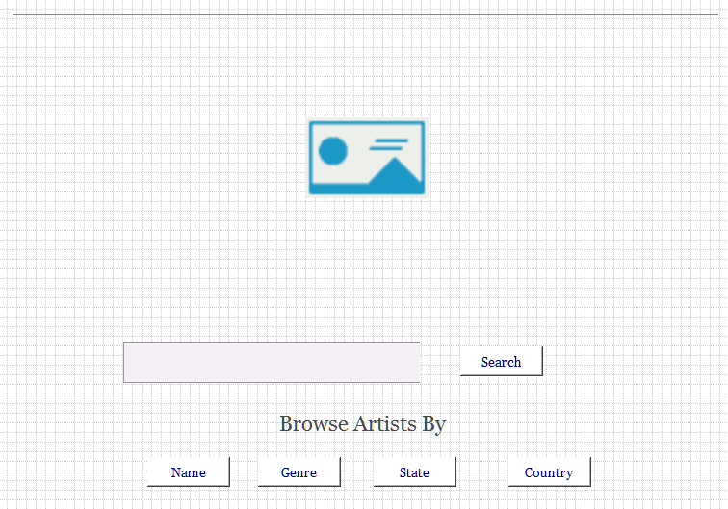

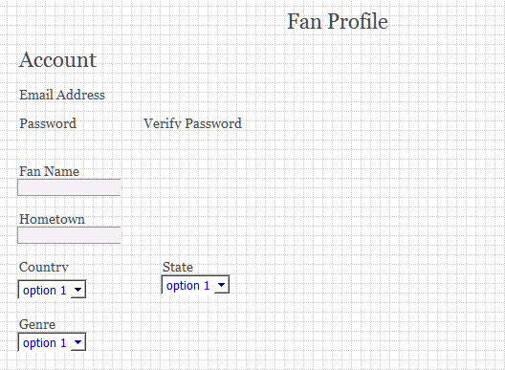
- The country drop down will be all current countries.
- The states will only show if the United States is selected from country.

Profile Pic
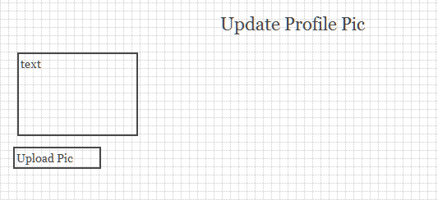
- Will show up after profile form submitted. Will hold onto the id assigned by Mongo. The picture will be saved to Firebase
- The firebase url will be written back to the fan record.

Footer
