Home Page

Logged In

Header
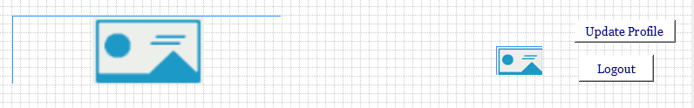
Notes:
- The header will feature a Logo.
- Will show the profile pic of the user logged in.
- Update Profile picture when clicked will show an update the correct update profile page by checking to see if an artist or fan is logged.
- Logout button when clicked will log out the user and redisplay the not logged in header and the trending artists page.

Menu
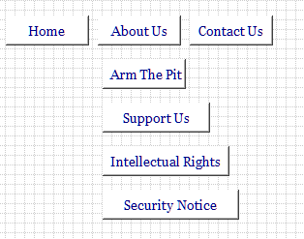
- The Home page will take you back to the home page of trending artists.
- About us will be a drop down.
  - Arm The Pit will take you to an about us page.
  - Support us will take you to a donate page.
  - The intellectual rights will take to the Intellectual Rights Page.
  - The Security Notice will take you to the Security Notice Page.
- The contact us will take you to the Contact Us Page.

Jumbotron
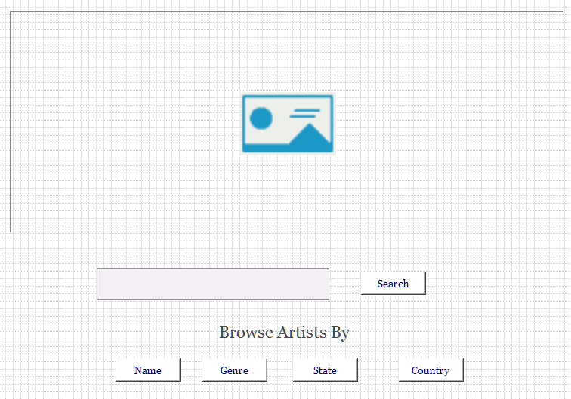
- The Jumbotron image will be a rock n roll image.
- The search will search the database looking only at artists meeting the search criteria. Will build a page showing all artists meeting the search criteria.
- The Name button will take you to the Browse By Name Page.
- The Genre button will take you to the Browse By Genre Page.
- The State button will take you to the Browse By State Page.
- The Country button will take you to the Browse By Country Page.

Trending Artists
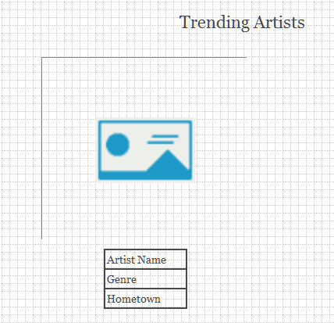
- An artist picture will be show. When hovered over a player will show and when clicked will play a song from the artist.
- The artist name will link to the artist profile page.
- The genre will link to the main page of the genre.
- The hometown will take you to the state or country if the artist is not from the United States.

Footer
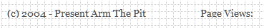
The Vistor views will display the number of unique visitors to the site.

