Main Content

Not Logged In

Header
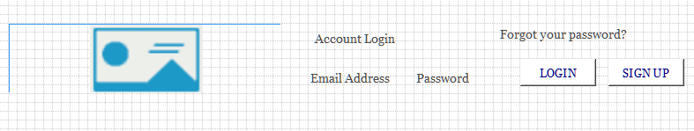

Menu
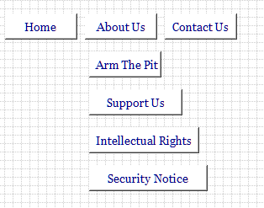

Jumbotron

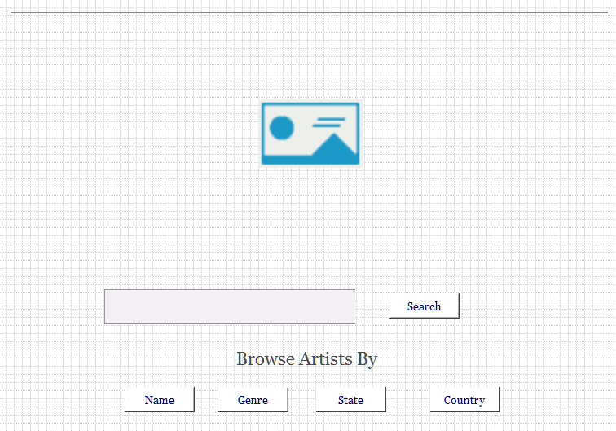 Body
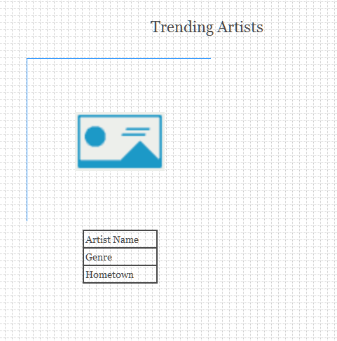
- This page will be used by all the pages to show the artists. It will have props passed to be used to search the database for the artists to be displayed.

Footer


