Forgot Password

Not Logged In

Header
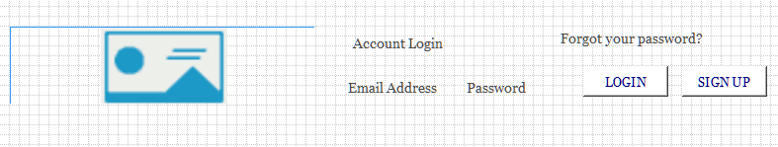

Menu
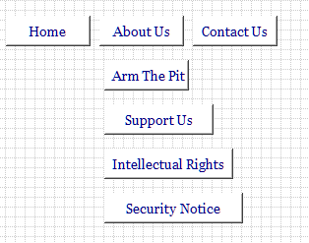

Jumbotron

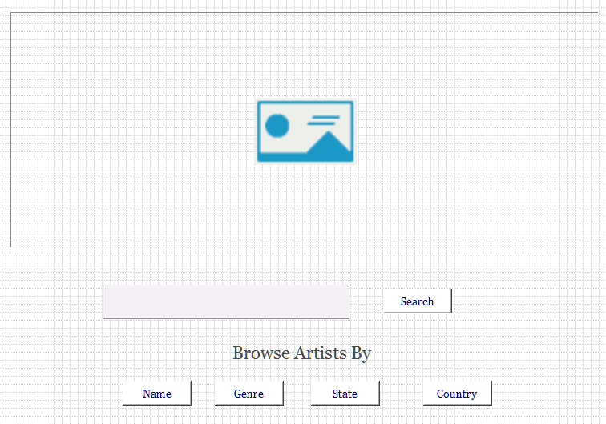 Forgot Password

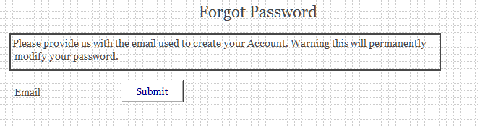

- Will allow a user to enter the password they used to sign up with and reset email will be send to them so they can reset their password.

Footer
