Sign Up

Not Logged In

Header
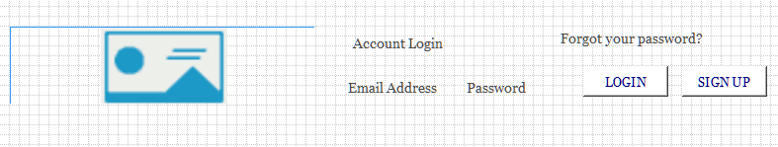

Menu
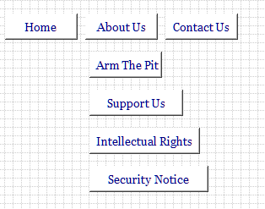

Jumbotron
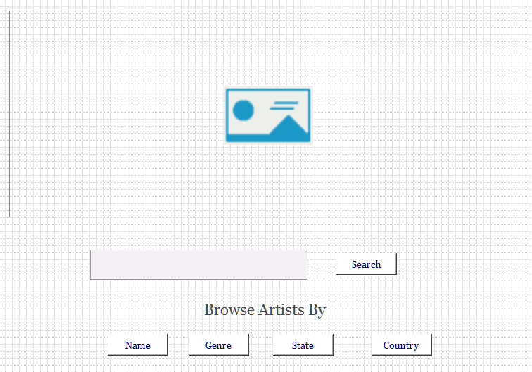

Sign Up
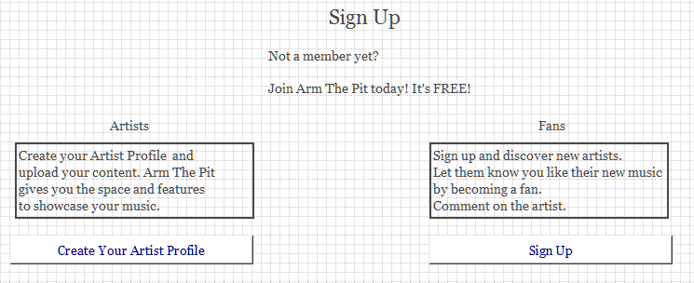
- This is the page which will be seen when the sign up button is clicked on the menu. If they are logged in it will go to the the main page of trending artists.
- Clicked on artists and it will take you to the artist sign up page.
- Clicked on fan and it will take you to the artist sign up page.

Footer
