Browse Artists By State

Not Logged In

Header
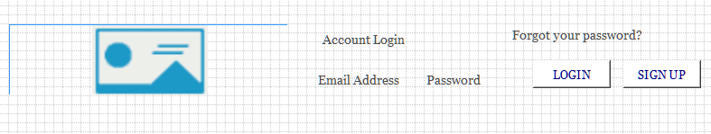

Menu
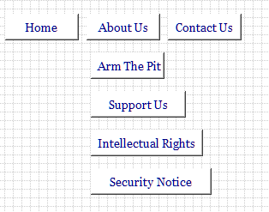

Jumbotron

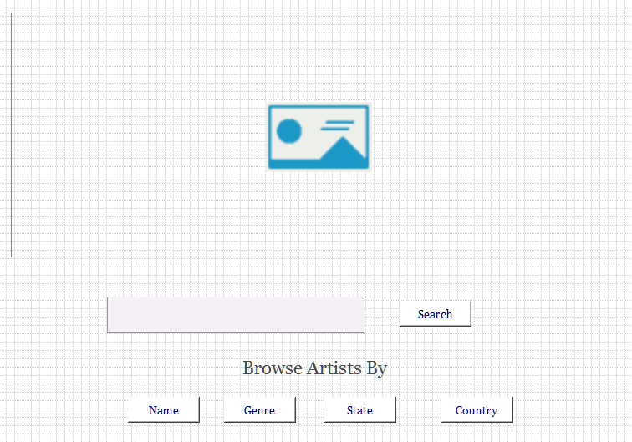 Body

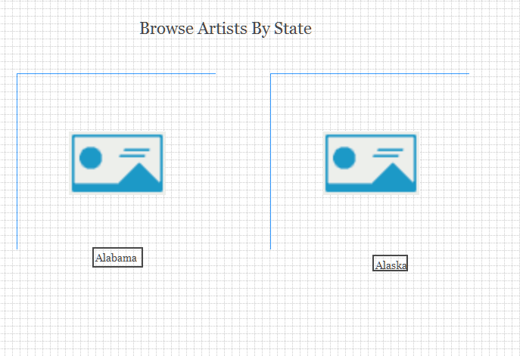
- Will show a picture of every state.
- When you click on a genre it will show the artists from that state.

Footer


